How to update your profile
Once you’re logged in, you’ll see your name in the upper portion of the screen
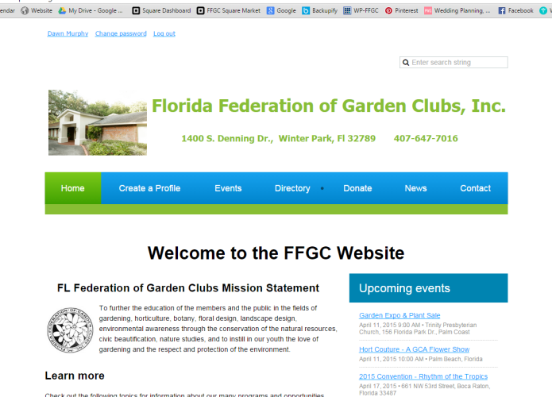
(It may be right or left depending on your display settings, browser, etc.)

Click on your name and you’ll be taken directly to your profile page.
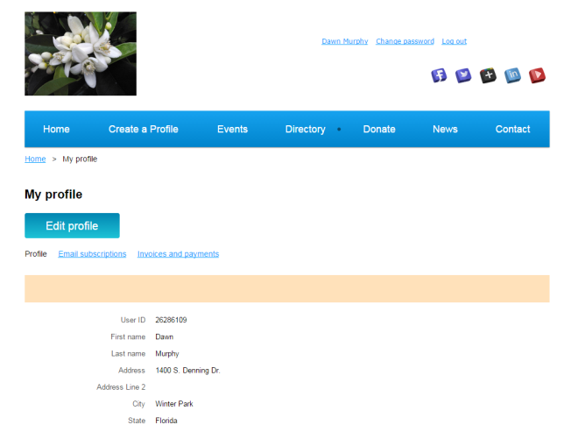
Click on EDIT Profile

Make any necessary
changes, add a picture

SAVE your changes by clicking on the Save button in the lower left

